SAINTGITS COLLEGE OF ENGINEERING (AUTONOMOUS) | 

AI BLEND FOR ENGINEERS - PROJECT
B.Tech. Third Year (2024-25 Admission)
Intermediate Evaluation Format
Title of the project | An AI-Powered Robotic System for Early Plant Disease Detection in Greenhouses
Project ID | 24AB046 | Name of the Supervisor | Dr. Preena Prasad
Names of team members | Amy B Chiramel | Batch | EEE
 | Hannah Maria Jacob |  | CSB
 | Aiben Koshy Cherian |  | RBA
 | Boby Joseph |  | EEE
 | Christy Roy |  | RBA

Project Objectives
(also include the relevance of project to community)
- To develop an AI-based image classification system capable of accurately detecting and identifying diseases in five major greenhouse crops — apple, corn, potato, strawberry, and tomato — from leaf images.
- To design and simulate a robotic platform capable of autonomously navigating greenhouse rows and capturing crop images for real-time disease screening.
- To integrate the trained deep learning model with an edge-computing unit for on-device inference, enabling low-latency disease detection without dependence on constant cloud connectivity.
- To build a decision and alert layer that logs detections with confidence scores and geo-tags, and notifies growers of early-stage disease outbreaks before they spread visibly across the greenhouse.
- To evaluate the system's classification accuracy, robustness across crop types, and feasibility for real-world greenhouse deployment.
Relevance to the community:
Plant diseases are a major cause of crop loss in greenhouse farming, often spreading rapidly before manual inspection catches early symptoms. Manual scouting is labour-intensive, subjective, and difficult to scale, particularly for smallholder and resource-limited farmers who cannot afford dedicated agronomists. This project offers a low-cost, automated alternative that helps small and marginal farmers reduce crop losses and input costs through targeted treatment; helps greenhouse operators improve yield consistency; supports food security by protecting staple and cash crops (corn, potato, tomato); and supports sustainable agriculture by enabling targeted intervention instead of blanket pesticide application.

Literature Review: Details of papers/materials reviewed
Corn / Maize (Hannah Maria Jacob):
Reviewed plant-pathology and AI literature on major maize diseases (southern corn rust, maize white spot, gray leaf spot, northern/southern leaf blight, tar spot, Fusarium ear rot). CNN ensembles on PlantVillage-derived maize subsets reach ~98.6% accuracy; a hybrid CNN–Vision Transformer achieves 99.15% test accuracy and 95.93% on an independent field dataset (CD&S), versus 89.7% for a CNN-only baseline. A weather-driven random forest model for tar spot forecasting reaches 90.1% accuracy.
Potato (Christy Roy):
Systematic review of 17 studies (2021–2026). PlantVillage-benchmarked models reach 97–99% accuracy (e.g. MobileNet-v1: 99.83%, custom CNN: 99.22%, CNN+ViT hybrid: 99%), but field-tested generalisation drops sharply — best field accuracy only 81.60% (DenseNet169), and a lightweight edge model (RegNetY-400MF) reaches 90.68% on uncontrolled field images. Also covers GAN-based augmentation, Grad-CAM explainability, and hyperspectral pre-symptomatic detection.
Strawberry (Amy B Chiramel):
Reviewed five studies spanning cascade Faster R-CNN with a plant-domain-pretrained backbone (91.65% mAP), deep-metric-learning open-set recognition (92.8% mAP), attention-augmented YOLOv8 (up to 98.26% mAP50), a lightweight YOLO11-Strawberry model (95.3% mAP50 at 27 FPS on Jetson Xavier NX), and D-YOLO, a MobileNetv3-based YOLOv8 variant generalising to maize with 94.5% mAP. Key challenges: class imbalance, small-target detection, no standardised benchmark dataset.
Tomato (Boby Joseph):
Reviewed five studies including a PlantDoc web app citing tomato accuracies of 87–99.23% across external sources, a Teachable Machine/TFLite Android app (94% overall across potato, tomato, corn), a custom CNN on 35,000 images across six crops (96.5% overall; 99.62% confidence for late blight vs. 75.36% for early blight), and a CNN vs. RF/RNN/LSTM benchmark (CNN: 98% accuracy). Notable finding: validation accuracy fell from 36% to 13% when the same architecture was evaluated on the field-condition PlantDoc dataset instead of PlantVillage.
Apple (Aiben Koshy Cherian):
Reviewed ten studies (2021–2025) spanning the full methodological progression for apple leaf disease detection: handcrafted-feature SVM pipelines (77.5%→92.5% accuracy depending on preprocessing), a lightweight custom 3-layer CNN matching nine pretrained backbones at 98% accuracy, DCGAN-augmented CNNs reaching 99.99% on a small original dataset of 319 images, a CapsNet + Water Wave Optimization + BiLSTM hybrid at 99.2% average accuracy, an improved YOLOv5 object detector (A-Net) reaching 94.8% mAP@0.5 for lesion localization, and two lightweight vision-transformer designs — AppViT (96.4% accuracy, ~1.3M parameters) and AppleViT (97.8% accuracy, sub-50ms mobile inference, with Layer-wise Relevance Propagation for interpretability) — that matched or exceeded much larger CNNs at a fraction of the compute budget. A supporting 45-study systematic review (2016–2024) found self-constructed datasets most common (~36%), PyTorch the dominant framework, and reported accuracies ranging from 63% to 99.8% depending on background complexity and evaluation protocol.
Recurring challenges: a persistent gap between lab-controlled and natural orchard-condition accuracy, visual confusion between Black Rot and Apple Scab, an accuracy–efficiency trade-off that hybrid CNN–ViT designs appear to break, and inconsistent train/test splits and disease taxonomies across studies that limit direct cross-study comparison.

Project Specification (Include software, dataset (including sample size and source) and hardware (if any) specifications)
Software:
- Python 3.x, PyTorch (model training/inference), torchvision (pretrained CNN backbones)
- OpenCV (image preprocessing), Google Colab (GPU training environment)
- ONNX (edge-inference export format)
Dataset:
PlantVillage dataset (Hughes & Salathé, 2016), publicly available via Kaggle — 54,304 total leaf images across 38 disease/healthy classes. A filtered subset of 23 classes covering Apple, Corn (maize), Potato, Strawberry, and Tomato is used for this project (see Sample Screenshots for the organised folder structure).
Hardware:
No physical hardware deployed yet. Planned edge-inference hardware for the robotic platform (e.g. Raspberry Pi or Jetson Nano with camera module) to be finalised in the implementation phase; a ROS2/Gazebo simulation is planned as an interim, low-cost demonstration of the robotic platform.

Design Diagram (Architectural diagram and any design diagram: UML, Circuit etc.)
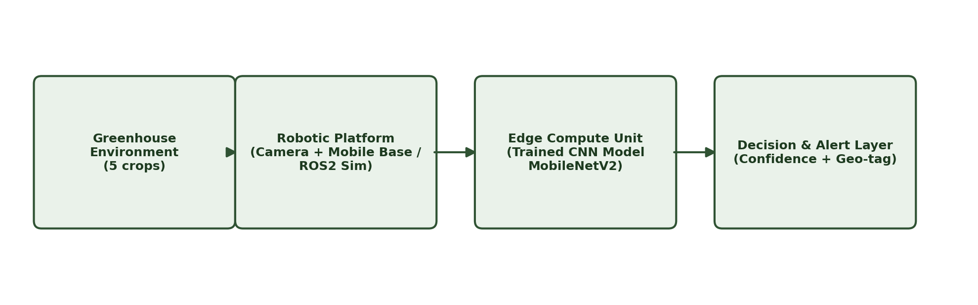
Pipeline: greenhouse crops are imaged by a camera-equipped robotic platform, processed on an edge compute unit running the trained CNN model (MobileNetV2 transfer learning), with outputs passed to a decision and alert layer that logs confidence scores and geo-tagged detections.

Progress of the work done : Give details of real-time implementation, if any
- Literature review completed for all five target crops (apple, corn, potato, strawberry, tomato).
- Dataset identified, sourced, and curated: the PlantVillage dataset has been downloaded and filtered down to the 23 class folders relevant to the five target crops (see Sample Screenshots for folder-structure evidence).
- A complete training pipeline has been implemented in PyTorch: data loading via ImageFolder, transfer learning on a MobileNetV2 backbone, train/validation/test split, evaluation reporting (accuracy, confusion matrix), and ONNX export for edge deployment.
- Model training has not yet been executed to completion; this is the immediate next step, with trained accuracy metrics and confusion matrix to be added ahead of the final submission.
- Robotic hardware integration / ROS2-Gazebo simulation is planned for the subsequent project phase, as per the project timeline.

Algorithm/Sample code
(give the git-hub repository details)
GitHub: https://github.com/Christy-Roy-tech/-Al-Powered-Robotic-System-for-Early-Plant-Disease-Detection-in-Greenhouses
Repository contains: the dataset preparation scripts, the PyTorch training script (MobileNetV2 transfer learning, train/val/test split, evaluation, ONNX export), and this documentation.

Sample screen shots/pictures
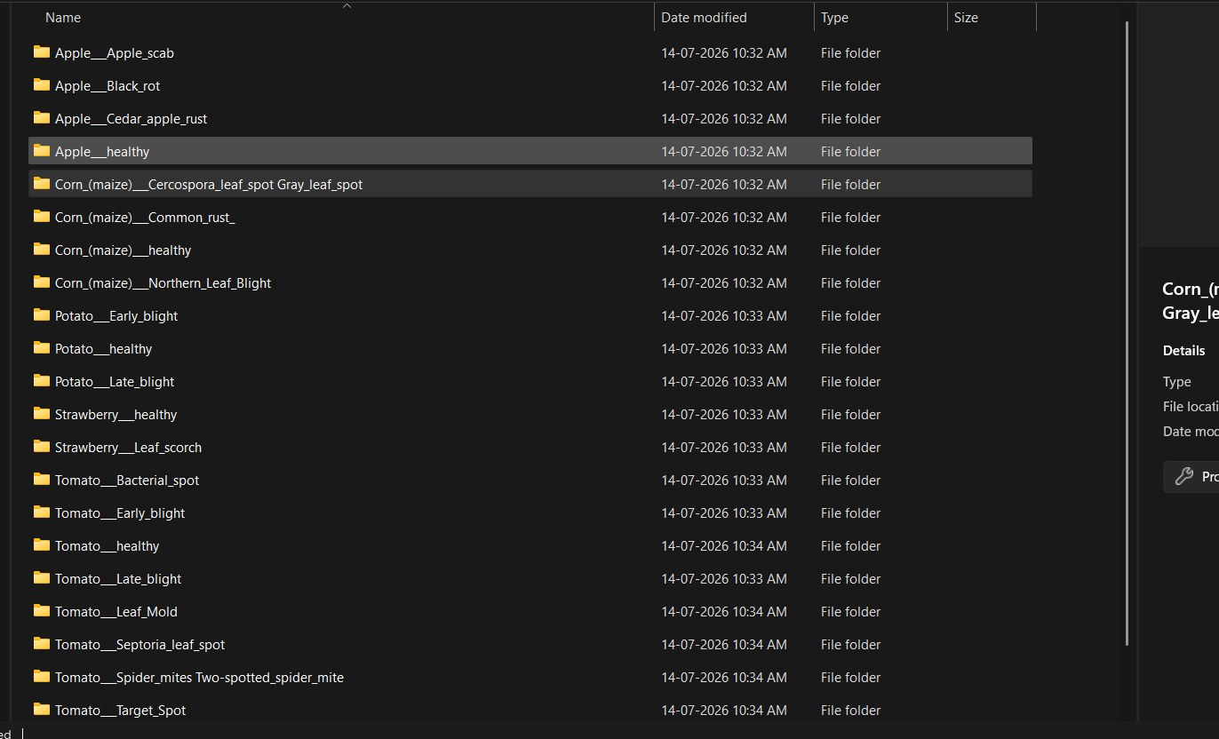
Filtered PlantVillage dataset — 23 class folders spanning apple, corn, potato, strawberry, and tomato, organised for the training pipeline.
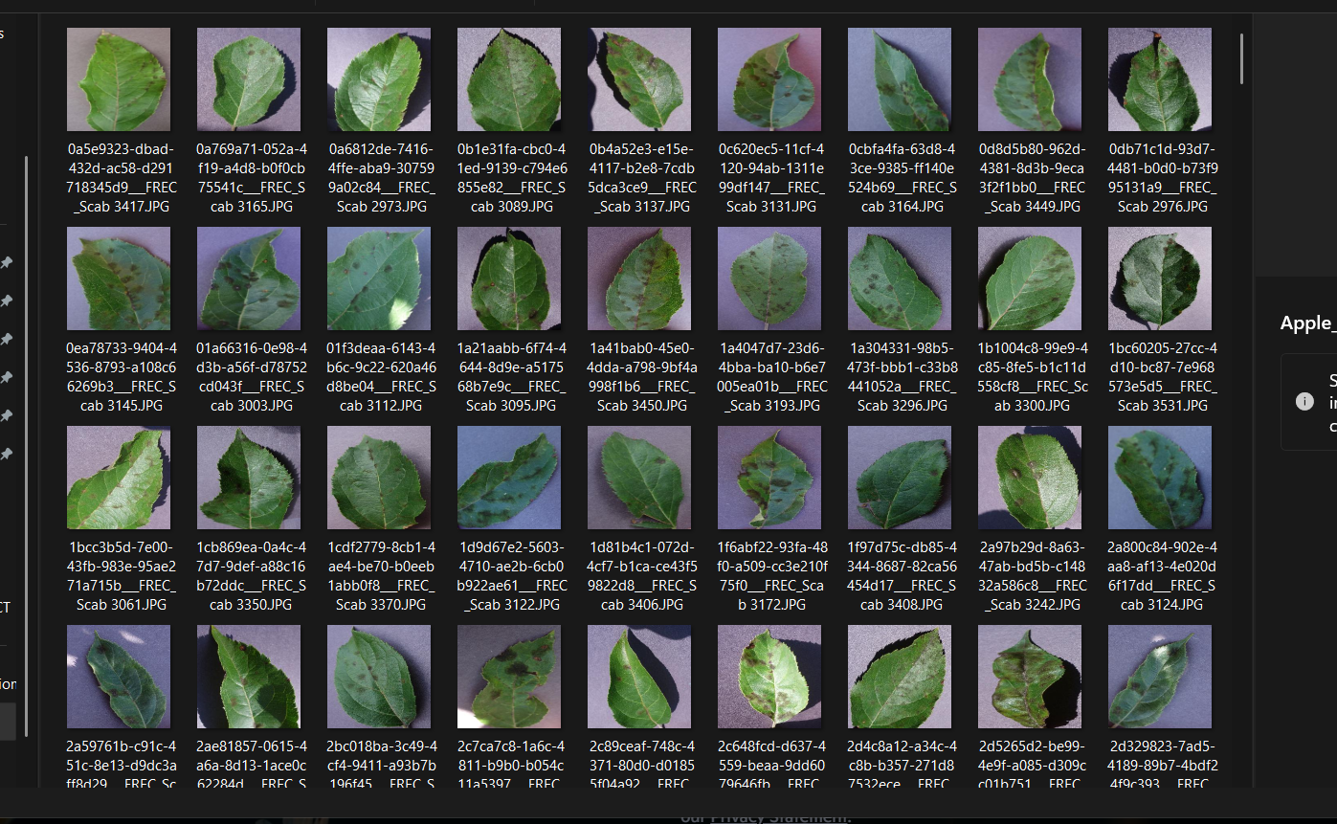
Sample images from the Apple___Apple_scab class, illustrating raw dataset content prior to training.

Name and Signature of Team members | Name and Signature of Supervisor
AI Blend for Engineers - Project

